DELHI TECHNOLOGICAL UNIVERSITY



STOCHASTIC PROCESSES

(MC-303)

PRACTICAL FILE

SUBMITTED TO:

PROF. H C TANEJA

MR. VINEET KUMAR

SUBMITTED BY:

NITYA MITTAL

(2K19/MC/089)

EXPERIMENT 3

# AIM

Demonstrating Poisson Process. WAP to find the probability that in case of Poisson process with rate λ, in a length of time t there are exactly k arrivals.

For example: Consider a transistor battery having exponential lifetime with mean as 2 months. In case six such spares batteries are available and if the time to replace a battery is negligible, find the probability that transistor will work for at least one year. In case mean failure times of the successive spare batteries are given by 2/n, then find this probability.

# THEORY

The Poisson Process is the model we use for describing randomly occurring events and by itself, isn’t that useful. We need the Poisson Distribution to do interesting things like finding the probability of a number of events in a time period or finding the probability of waiting some time until the next event.

The Poisson Distribution probability mass function gives the probability of observing k events in a time period given the length of the period and the average events per time:

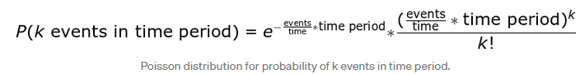

This is a little convoluted, and events/time * time period is usually simplified into a single parameter, λ, lambda, the rate parameter. With this substitution, the Poisson Distribution probability function now has one parameter:

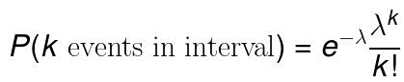

Lambda can be thought of as the expected number of events in the interval. (We’ll switch to calling this an interval because remember, we don’t have to use a time period, we could use area or volume based on our Poisson process). I like to write out lambda to remind myself the rate parameter is a function of both the average events per time and the length of the time period but you’ll most commonly see it as directly above.

As we change the rate parameter, λ, we change the probability of seeing different numbers of events in one interval. The below graph is the probability mass function of the Poisson distribution showing the probability of a number of events occurring in an interval with different rate parameters.

## SOURCE CODE and output

